**AIM:** Write a C program to implement hashing using Linear Probing method

**ALGORITHM:**

1. **Start**
2. Initialize a hash table with all positions set to -1 (empty).
3. **Insert (value):**
   * Compute hash index = value % SIZE.
   * If the slot is empty → place the value.
   * If occupied → move sequentially (linear probing) (index+1) % SIZE until an empty slot is found.
4. **Search (value):**
   * Compute hash index = value % SIZE.
   * Check slot:
     + If matches → found.
     + If empty → not found.
     + Else → probe sequentially until found or table fully searched.
5. **Display:**
   * Print the contents of the hash table with index.
6. **Repeat insert/search/display until exit is chosen.**
7. **Stop**

**CODE:**

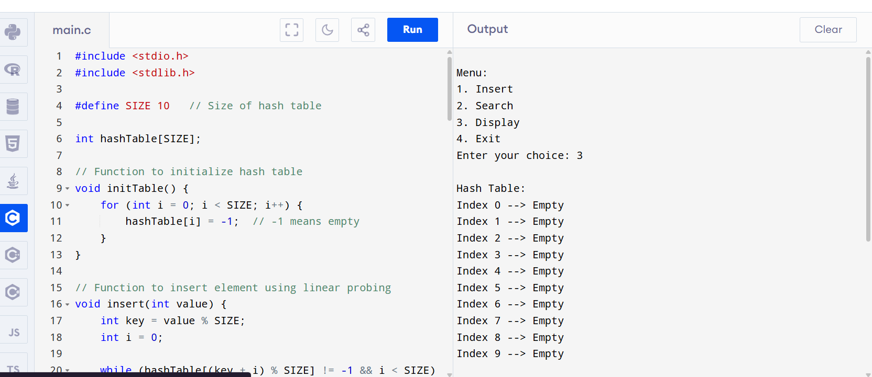

**OUTPUT:**

Menu:

1. Insert

2. Search

3. Display

4. Exit

Enter your choice: 3

Hash Table:

Index 0 --> Empty

Index 1 --> Empty

Index 2 --> Empty

Index 3 --> Empty

Index 4 --> Empty

Index 5 --> Empty

Index 6 --> Empty

Index 7 --> Empty

Index 8 --> Empty

Index 9 --> Empty